Specialty Pricing Issue

A recent specialty pricing issue was identified where some members may have been either overcharged or undercharged for a specialty drug.

Impact: Some SilverScript INDV PDP plan members that filled specialty medications during Jan 1, 2020 thru Sept 11, 2020 were impacted. The issue has been resolved and efforts to remediate are in place. If overcharged, the member will receive a refund, if undercharged, the member will receive an invoice. See attached sample letters.

Sample of the letter
Invoice and Refund
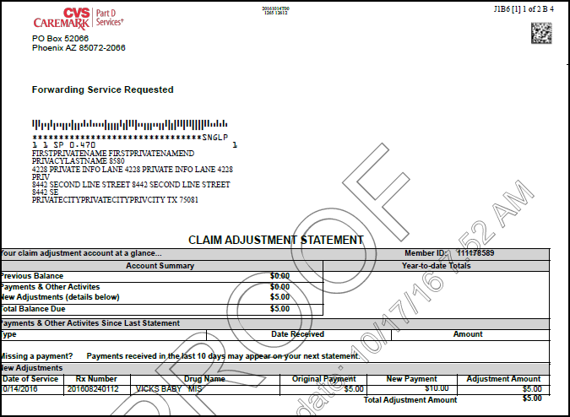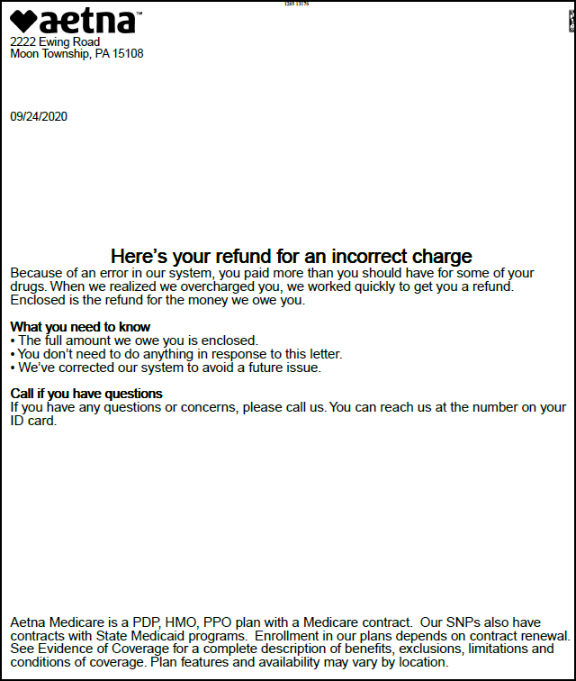

Action Required: If you receive a call from a member who has received a refund or payment letter due to this issue.
- Show empathy and understanding when answering the member’s concern
- Let them know we discovered a pricing issue in reference to specialty drugs
- The issue has been resolved
- They received a letter (see samples above) due to their claim being re-processed
  - If a refund they can cash or deposit the check
  - If request for payment
    - Explain the amount listed on the letter is the difference on a specialty medication received between 1.1.2020 and 9.11.2020. (could be multiple times)
    - We do apologize for any concerns this may be causing them
    - They can mail the payment listed on the letter
      - if they want to know what medication or when it was delivered offer to warm transfer to CVS Specialty Pharmacy
      - if they ask if we are going to send them to collections or report this to the credit bureau for non-payment.
        - No, we will not send them to collections or report this to the credit bureau.
- Answer any additional questions or concerns
- Summarize and document the reason for the call and any actions taken
- Thank the member for calling

Top of the Document
Not To Be Reproduced Or Disclosed to Others Without Prior Written Approval
ELECTRONIC DATA = OFFICIAL VERSION – PAPER COPY – INFORMATIONAL ONLY

